Evolving Indian Deterrence Doctrine: An Assessment
Colonel (Dr) Amitabh Hoskote (Retd)

Byline
At the one-year anniversary of Operation Sindoor, India has accelerated a doctrinal shift toward Multi-Domain Operations, articulated through a reconfigured Dynamic Response Strategy. The revised strategy places greater emphasis on jointness in planning and execution while retaining escalation dominance, particularly under the shadow of Pakistan’s nuclear deterrent.

New Paradigm in India – Offensive Defence
Operation Sindoor, conducted in May 2025 and lasting under four days prior to the ceasefire, generated sharply conflicting Indian and Pakistani narratives. India presented it as the debut of a new “Offensive Defence” posture, a calibrated retaliatory strategy against terror attacks originating from Pakistan. Pakistani authorities denied Indian claims of air superiority and sought to minimise the impact of precision strikes on air bases, radar sites, and a nuclear facility. The dispute persisted until a neutral assessment by Adrien Fontanellaz at the Centre for Military History and Perspective Studies (CHPM) in Switzerland largely settled the controversy.

The episode crystallised India’s Dynamic Response Strategy (DRS), a doctrinal model building/strengthening earlier framework but stressing inter-service integration and advanced technologies. DRS now governs Indian military responses to Pakistan. It is designed against the backdrop of Pakistan’s long-standing, sub-threshold sponsorship of terrorism – its “bleeding by a thousand cuts” approach articulated under General Zia-ul-Haq. The DRS retains escalation dominance between two de facto nuclear powers, collapsing the earlier distinction between state and non-state aggression, treating sub-conventional attacks as part of a single conflict spectrum. Positioned as an enabler of Multi-Domain Operations (MDO) across land/air/sea/cyberspace, it authorises punitive, non-territorial responses that deliver calibrated political signalling. Its technology-intensive, non-contact, precision-strike orientation allows rapid, controlled conflict termination once objectives are met. Long-range vectors – stand-off missiles, rockets, drones – operationalise this tenet; for instance, Rafale and Mirage aircraft striking terror hubs at Bahawalpur and Muridke with BRAHMOS and SCALP missiles, while AKASH and S-400 systems providing layered air defence. It is thus poised as the quintessential amalgamation of the four strategic pillars of Deterrence, Compellance, Integrated Defence, and Reconstitution.
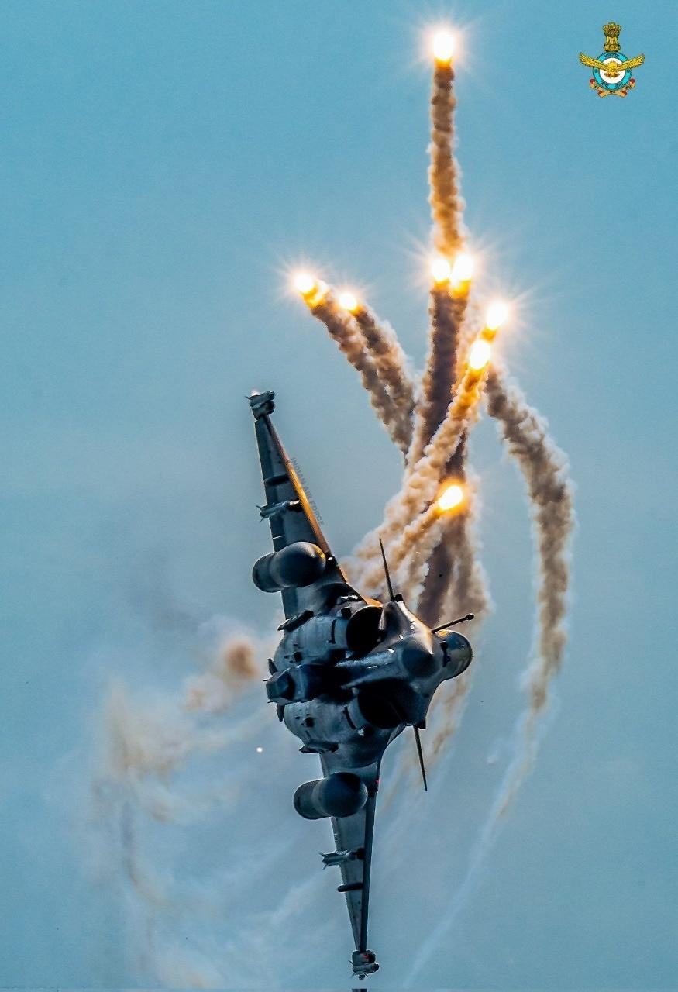
CHPM Report
In January 2026, CHPM published Operation Sindoor: The India–Pakistan Air War (7–10 May 2025) by Adrien Fontanellaz. The report categorically concluded that Pakistan’s initial tactical advantage in downing Indian aircraft was rapidly offset by India’s integrated air defence, which prevented successful strikes on Indian territory; while progressively degrading Pakistani air defences and key airbases, compelling Islamabad to accept a ceasefire. It reaffirmed the operational value of long-range stand-off capabilities, simultaneously noting the renewed use of conventional strike options between two de facto nuclear powers carrying inherent escalation risks. It underscored a doctrinal evolution in India toward assured retaliation for terror attacks, erasing the earlier distinction between terrorist organisations and their state sponsors, now treated as functionally inseparable and therefore legitimate targets for higher-order punitive action.

While the report acknowledged the difficulty of independently verifying competing claims from both sides, it nevertheless accepted this significant politico-strategic shift in South Asia. The Indian military was credited with containing escalation despite holding a battlefield advantage, and with improving information operations by systematically recording and releasing real-time imagery from strikes. It underlined the growing importance of long-range stand-off weapons integrated with layered air defences, while cautioning that the proliferation of drones served to erode the relative effectiveness and cost-efficiency of such systems [1]. Overall, the CHPM report vindicated India’s doctrinal shift against a nuclear-armed adversary: collapsing the state/non-state distinction and endorsing decisive retaliation for terror attacks on Indian soil. While India sought calibrated and rapid de-escalation once objectives were met, the report warned that Pakistan’s responses may not mirror this restraint, leaving the risk of escalation to the nuclear threshold persistently high, and therefore central to planning for future crises.
Indian Military Establishment: Strategic & Doctrinal Viewpoints
DRS represents an evolutionary refinement of earlier Indian doctrines. The 1980s Sundarji Doctrine [2] envisaged deep armoured thrusts into Pakistan’s hinterland to dissect the country, destroy warfighting capacity, and induce internal collapse. In the wake of Operation Parakram (2001–02), emphasis shifted to rapid mobilisation, surprise, and limited, objective-oriented thrusts under the Cold Start concept [3], incorporating an explicit nuclear threshold and drawing on the US Air-Land Battle model to enhance inter-service integration. Escalating terrorist attacks on Indian soil and the perceived political costs of restraint gradually made punitive responses appear unavoidable. Diplomatic efforts to highlight Pakistan’s sponsorship of terrorism, coupled with its continued support to such elements, shaped public and elite consensus that a harder response was necessary; the killing of tourists at Pahalgam in April 2025 proved the tipping point. Within the military, a strong retributive impulse, aligned with political signalling, drove force restructuring and technology infusion to align capabilities with this emerging posture.

Senior leadership has publicly framed Operation Sindoor as a vindication of these reforms. The Army Chief has highlighted “domain jointness” and tri-service synergy in a grey-zone environment; the Air Chief has stressed clear objective selection and rapid conflict termination; the Navy Chief has noted that sea-based strikes were minutes from launch; and the CDS has pointed to Pakistan’s subsequent reconfiguration of its rocket forces as evidence of operational impact. Parallelly, military-linked scholarship has reinforced this doctrinal shift. Red Lines Redrawn: Operation Sindoor & India’s New Normal by Major General Bipin Bakshi, Air Marshal Rajesh Kumar, Ambassador Anil Trigunayat, and Brigadier Akhelesh Bhargava, launched by the Army Chief, is the portrayal of a new regional normal, with India’s actions compelling Pakistan to reassess its proxy-war strategy. Emphasizing India’s decision not to declare formal closure of the operation, the authors posit that this deliberate ambiguity is sustained to underpin both deterrence signalling and cost-imposition for Pakistan’s protracted state-sponsored terrorism through grey-zone means.
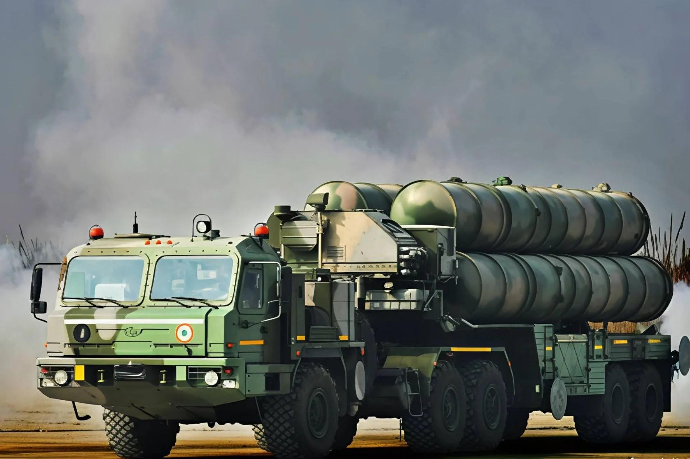
Critiques and Countervails
Given its magnitude, Operation Sindoor — and the doctrinal shift symbolised — inevitably attracted intense scrutiny. Its triggers, conduct, and termination, as well as the evolution of Indian military doctrine, find examination through partisan politics. Volatility of India–Pakistan hyphenation is especially emotionally charged, and one finds verbose public debate, routinely alongside more robust policy and academic analysis. India’s attribution of the Pahalgam attacks to Pakistan without publicly shared, conclusive evidence has been sharply criticised, particularly on social media, after Islamabad invited a neutral third-party inquiry; some quarters regard it as a strategic misstep by New Delhi. This perception is reinforced by the continuing failure to arrest the perpetrators. Early operational reverses, not officially acknowledged at the time, fuel allegations of cover-ups and under-utilisation of high-end assets such as Rafale aircraft, as well as concerns about their performance vis-à-vis Pakistan’s Chinese-origin J-10s.

India’s regional image as a net security provider has also suffered. The US president’s public claim of credit for brokering the ceasefire, and India’s muted rebuttal, are viewed as allowing narrative space to slip away. Pakistan’s apparent rehabilitation with Washington — culminating in its mediatory role in the Iran conflict — is interpreted as a further blow to India’s standing. Operation Sindoor and the rollout of DRS have drawn only limited international support, without the hoped-for categorical censure of Pakistan, while also being criticised for elevating nuclear-escalation risks. Collectively, these developments are often read as strategic setbacks for India in geopolitical and foreign-policy terms. India’s strategic community has seen heated debates on the trade-off between tactical success and strategic coherence; the operation punctured Pakistan’s belief in nuclear immunity, yet it is argued that vague strategic end-states, coupled with apparent acceptance of a US-driven ceasefire, enabled Pakistan’s rapid internal and external recovery.

Consequently, India’s deterrence posture appears less certain, at least along structural dimensions: choices between restraint and retaliation; a shift in international responses from broadly supportive to ambivalent or even critical; and regional dynamics that now seem to marginalise India relative to earlier expectations. Lieutenant General DS Hooda, one of India’s notable leaders in military thought, identifies key conditions for success in this context: clear institutional and political ownership of the new doctrine; acceptance of altered roles, resources, and command relationships; overhaul of procurement and development of a credible military-industrial base; and sustained investment in technology-centric thinking and training.

Strategic Evaluation & Key Vectors in Doctrinal Development
Structural Vulnerabilities of Multi-Domain Operations
Multi-Domain Operations (MDO) presuppose seamless, centralised command, resilient networks, and continuous data fusion across domains. Their very strength thus becomes a critical vulnerability: disruption in cyber, space, or the electromagnetic spectrum can fracture coordination, degrade bandwidth, and delay or distort intelligence flows. When synchronisation across domains and echelons falters, situational awareness erodes, agility declines, and the promised convergence of capabilities fails to materialise in high-intensity environments. Unless these risks are explicitly incorporated into planning, exercising, and redundancy design, MDO may remain more aspirational than operational, with commensurate losses in effectiveness.
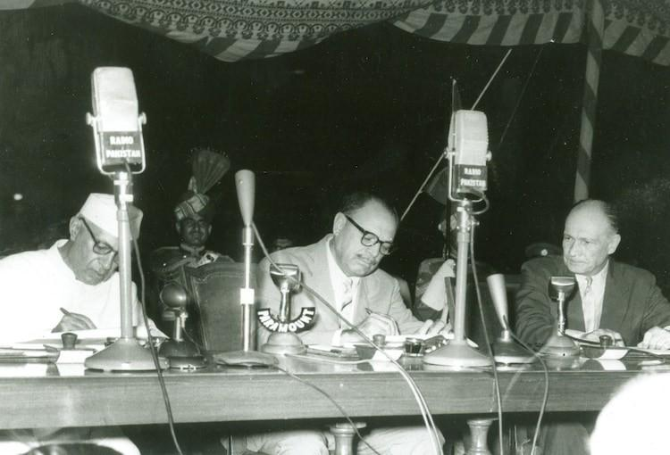
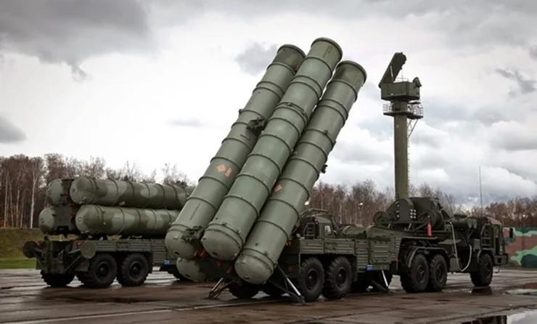

Force Structure Economics and Platform Mix
While indispensable in certain roles, high-end platforms cannot by themselves resolve asymmetric contests. Globally, transformational developments increasingly find favour in the utilisation of relatively low-cost, mass-produced systems — especially unmanned platforms — precisely because such technology complicates an adversary’s calculus at minimal/ sustainable cost. India’s continued emphasis on an expensive combat aviation fleet must therefore be balanced by deliberate investment in indigenous missiles, rockets, and drones. A judicious force mix — combining exquisite platforms where necessary, with scalable, cost-efficient systems — requires a closer fusion between the military and an indigenous industrial base oriented toward emerging technologies and serial production.

Strategic Alignment of Diplomacy and Defence
A posture of loosely defined “strategic autonomy” without clear, issue-based alignments yields limited strategic leverage, especially in a fluid and rapidly evolving international system. India’s relatively muted diplomatic profile stands in contrast to Pakistan’s recent positioning as a mediator in the Iran conflict, which has enhanced Islamabad’s diplomatic capital and future bargaining options. For India, recalibrating foreign policy so that diplomatic initiatives more directly reinforce deterrence, crisis-management, and long-term security objectives has increasingly become a matter of strategic necessity, rather than choice.

Contestation in the Information Domain
The battle for narratives – information and psychological operations – now constitutes a core battlespace, not a peripheral adjunct any longer. Losing the narrative is functionally equivalent to fighting with diminished combat power. India has improved its management of strategic communications in recent crises, yet its capability remains uneven and reactive. A professionalised, technology-literate communications cadre, embedded within policy and security institutions, should be treated as a doctrinal requirement. Narrative dominance also matters where security and policy debates intersect — as with the Indus Waters (IWT) — where unchallenged commentary risks consolidating opinion against Indian positions. Proactive framing can advance India’s bilateral and multilateral objectives more effectively than ex post facto rebuttals.

Doctrinal Design: Prescriptive Versus Descriptive Paradigms
Doctrine, as a subset of grand strategy, cannot and should not be merely a catalogue of current practice(s) but a principal instrument for shaping future force design and employment. In hierarchical organisations, it carries normative weight and can be used to close capability gaps and reorient thinking – but provided it is imbibed prescriptively [4]. Treating the Dynamic Response Strategy as a living, prescriptive framework will encourage debate, experimentation, and conceptual refinement; rather than allowing it to ossify into a descriptive, post-hoc justification of what has already occurred.

Critical Junctures and Strategic Pathways
From an international relations perspective, the current India–Pakistan hyphenation – embedded within a wider reordering of global equations – constitutes a critical juncture: a moment capable of altering institutional trajectories over decades. Such junctures can either entrench existing patterns or catalyse substantive change. Recognising this inflexion point, Indian analysts and policymakers must anticipate external shifts and thereby adapt doctrine, force posture, and diplomacy accordingly. Failure to do so risks a generational forfeiture of strategic opportunity and a slow, structural marginalisation.

Internal Security Introspection and Non-Kinetic Deterrence
Evolution of cross-border terrorism, including use of “white-collar” facilitators embedded within Indian systems, exposes internal seams that adversarial agencies can exploit. This necessitates introspection about domestic policies and socio-institutional conditions that create propitious environments, as well as a shift toward intelligence-driven internal counter-measures. Systematic monitoring of digital ecosystems, mapping of sleeper networks, and scrutiny of vulnerable institutions (educational, religious, and intellectual) will blunt proxy/homegrown threats. A robust internal security architecture of this kind can, over time, reduce the frequency and necessity of kinetic India–Pakistan confrontations.
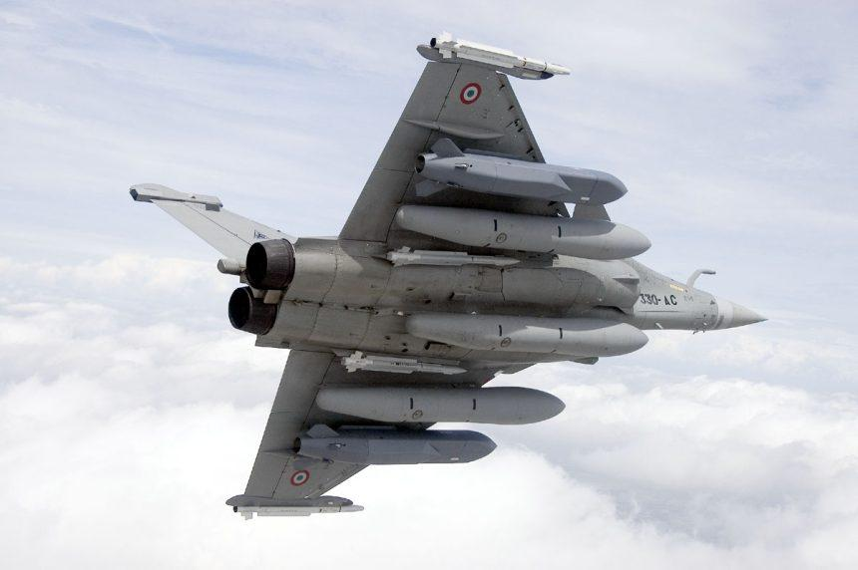
The Denouement
Institution of a series of measures post–Operation Sindoor by India is intended to counter escalating state-sponsored terrorism. Foremost among them is the doctrinal revision designed to enable credible punitive action against Pakistan. In this framework, earlier distinctions between the Pakistani state and non-state actors operating under its aegis have been deliberately eliminated. The Dynamic Response Strategy (DRS) is conceived as a calibrated, technology-intensive construct, privileging deterrence, compellance, (inter-service) integrated defence, and reconstitution – within a multi-domain operational environment.

Indian military reforms now prioritise accelerated jointness through Theatre Commands, deeper indigenisation via strengthened defence–industrial linkages, and systematic infusion of emerging technologies. Particular emphasis is placed on cost-effective capabilities, long-range vectors, and enhanced stand-off engagement through air, rocket, missile, and drone systems. In parallel, India is moving toward pre-emptive neutralisation of cyber threats in the grey zone, leveraging socio-economic instruments such as the IWT, raising technology-oriented specialised units, deploying layered air-defence architectures, and integrating kinetic with non-kinetic means of coercion. Offensive Defence is thus positioned as India’s “new normal” within a forward-leaning deterrence and dominance posture.

This assessment synthesises a wide spectrum of academic, official, and public views, isolating key vectors warranting heightened policy attention; simultaneously, recognising the insufficiency of doctrinal refinement on its own. Sustainable and credible deterrence entails coherent, whole-of-government approaches; joint and collaborative implementation, sustained political backing, and resource prioritisation, ensuring operational effectiveness against an evolving threat landscape, especially under a nuclear overhang.

[1] Iran war serves as a template for military strategists, the use of drones by Iran has put paid to much more expensive and superior technologies in use by the US & Israel. It has proven to be the assertion assisting/ overcoming asymmetry faced by armies fighting stronger/ superior enemies.
[2] Designed by late Gen Sundarji, then Chief of Army Staff, it essentially envisaged a classic armour-led brush across Pakistani territory, destroying armour-based reserves (Army Reserve North & South – ARN & ARS respectively), dissecting the country, and decimating future warfighting potential.
[3] It called upon extremely tight timelines for the mobilisation & launch of troops into Pakistan. With mobilisation in 48-72 hours, it moved peacetime deployments closer to the border. Force restructuring measures sharpened the ‘teeth’ – integrated fighting & logistics elements, with stress on reduced logistics ‘tail’.
[4] Debate persists regarding the efficacy of doctrine, with views ranging from its insufficient rigidity to drive change, to its role as a merely post-hoc rationalisation of shifts already underway. Its practical impact varies by context: doctrine operates (or fails to do so) in line with organisational ethos, the quality of internal debate, and the way it shapes – and reshapes – conceptual military employment, all of which bear directly on its effectiveness.

